

Establishing a Comprehensive Spirometry Database for COPD Diagnosis and Clinical Prediction

Final Report
Under-Graduate Final Project
Submitted toward the degree of
Bachelor of Science in Biomedical Engineering

By

Noa Diskin
206039877
Daniel Hagendorf
318879715

Supervised by Dr. Doron Schwarts Cohn

August 2025

Establishing a comprehensive Spirometry database for COPD diagnosis and clinical prediction

Daniel hagendorf ¹, Noa Diskin ¹, Doron Schwarts Cohn ²

¹ Department of Biomedical engineering, faculty of Engineering, Tel Aviv University

² Pulmonary institute, Tel Aviv Sourasky medical center (Ichilov hospital)

Chronic Obstructive Pulmonary Disease (COPD) is the third leading cause of death worldwide, posing a major health challenge due to progressive airflow limitation and frequent diagnostic delays. Although spirometry remains the gold standard for diagnosis-typically defined by a Forced Expiratory Volume in the first second (FEV₁) to Forced Vital Capacity (FVC) ratio below 0.7-its clinical use is hampered by underutilization and a lack of structured, high-quality data. This project addresses the diagnostic gap by developing an automated tool to extract spirometric parameters from diverse PDF report formats using Optical Character Recognition (OCR), and integrating these into a dynamic, validated database. Our Python-based system achieved over 80% extraction accuracy across seven distinct report formats, with fewer than 5% undetected errors in key fields. Crucially, the system calculates Global Lung Initiative (GLI) reference values, which are the clinical gold standard for COPD assessment but are rarely used due to computational complexity. By standardizing data extraction, enabling GLI-based classification, and building a scalable database, this tool improves diagnostic precision and paves the way for advanced research in patient stratification and predictive modeling through machine learning and deep learning.

Introduction

COPD pathophysiology
Chronic Obstructive Pulmonary Disease (COPD), the world's 3rd leading cause of death [1], is a prevalent and debilitating respiratory condition characterized by chronic symptoms such as dyspnea, persistent cough, and sputum production. It is caused by abnormalities in the airways and alveoli, leading to progressive airflow obstruction. COPD remains a major global health concern, with over 300 million individuals affected worldwide, and it significantly contributes to morbidity, mortality, and healthcare costs. The primary risk factors include tobacco smoking, air pollution, and occupational exposures, with a disproportionate burden observed in low- and middle-income [1],[2].

Diagnosis and symptoms
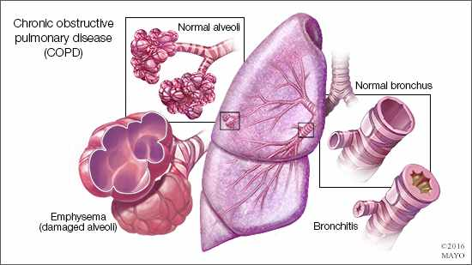
COPD diagnosis is based on spirometry, which demonstrates fixed airway obstruction. This is assessed by dividing the Forced Expiratory Volume during the 1st second of exhalation (FEV1) by the Forced Vital Capacity (FVC). A FEV1/FVC ratio below 0.7 is typically diagnostic of COPD. However, this simplistic criterion encompasses diverse patient populations with distinct clinical phenotypes. For example, while some patients primarily present with excessive mucus secretion, others suffer from emphysema-characterized by the destruction of lung parenchyma (Fig. 1), immune system overstimulation, or fibrosis. Additionally, the FEV1/FVC ratio does not correlate with the risk of exacerbation, making predicting disease progression difficult. The only available biomarker, eosinophil blood count, signifies type 2 inflammation in a small subset of patients. These limitations highlight the need for improved diagnostic tools to better understand and manage COPD.

Figure 1. Common phenotype presentations of COPD- Emphysema (left) and Chronic Bronchitis (right)[3]

Challenges in Spirometry Utilization
Spirometry is underutilized in many clinical settings, contributing to significant issues of underdiagnosis and overdiagnosis. Retrospective studies often include patient populations without formal spirometric confirmation of COPD. For example, patients are sometimes grouped based on clinical diagnosis alone, which can lead to inaccuracies. Studies show that up to 26% of symptomatic individuals with spirometric evidence of COPD remain undiagnosed, while 25–50% of patients clinically labelled with COPD lack objective confirmation [1], [2]. Building a robust database to study COPD requires strict inclusion criteria to ensure cases are properly defined. However, the lack of validated and comprehensive databases of clinically confirmed COPD cases presents a significant challenge. Existing repositories often rely on administrative records or self-reported diagnoses, which lack the precision needed for reliable research and personalized care. This gap hinders the development of robust diagnostic frameworks, limits epidemiological exploration, and prevents the integration of advanced analytical methods into COPD research[1]. These limitations underscore the urgent need for an objective, automated tool to standardize COPD diagnosis, improve data accuracy, and support predictive analytics for better patient outcomes.
Despite the widespread prevalence and significant burden of COPD, current diagnostic practices are hindered by the underutilization of spirometry and the absence of robust, clinically validated databases. To address this gap, the proposed project aims to develop an objective tool that leverages spirometry data accumulated in the newly created database to assess individual COPD patients and predict their clinical course.

Objectives
This project aims to create an automated system for extracting key parameters from spirometry tests, ensuring diagnostic accuracy, and facilitating real-time data integration into a dynamic, continuously expanding database. This database will serve as a cornerstone for advanced analytical studies, enabling the classification of new and existing COPD cases. Furthermore, it will leverage machine learning (ML) and deep learning (DL) algorithms to uncover novel clinical insights and improve patient stratification for therapeutic interventions. By addressing the limitations of current diagnostic practices and establishing a validated resource for COPD data, this project seeks to enhance early detection, reduce misdiagnosis, and provide a foundation for innovative clinical research.

Methods

Data Acquisition
Following institutional approval (Helsinki), a structured SQL query was executed on the hospital database to retrieve patient information. The query extracted patient IDs, links to spirometry test scans, results of the most recent blood tests, scan dates, and physician diagnoses. For each patient record, the exported Excel file was processed using a Python script implemented with the ‘pandas’ library. A link crawler, developed with the ‘urllib’ library, automatically navigated to the provided links and downloaded the corresponding spirometry reports in PDF format. These reports were then passed into the main extraction pipeline for further processing and reintegration into the database.

PDF Extraction
Spirometry reports were provided in PDF format, with numerical data embedded as images rather than machine-readable text. Each page was therefore converted into JPEG format using the pdf2image library. The resulting images were subjected to Optical Character Recognition (OCR) using both Tesseract and ‘EasyOCR’. To improve recognition accuracy, images were pre-processed by conversion to grayscale, followed by binarization using a fixed threshold. OCR output was parsed with an extensive set of regular expressions tailored to the various report formats, enabling structured extraction of key parameters.
The pipeline was designed to accommodate the diversity of spirometry report formats produced by multiple machines in use at the institute. These formats were classified within the algorithm as either “old” or “new,” based on structural layout, which reflected differences in equipment generation and software versions. The older formats typically present results in a simple tabular structure, whereas the newer formats employ multi-column layouts with additional graphical elements (Figure 3). Notably, not all tests were performed specifically for COPD diagnosis but also for the evaluation of other pulmonary conditions, further contributing to format variability.
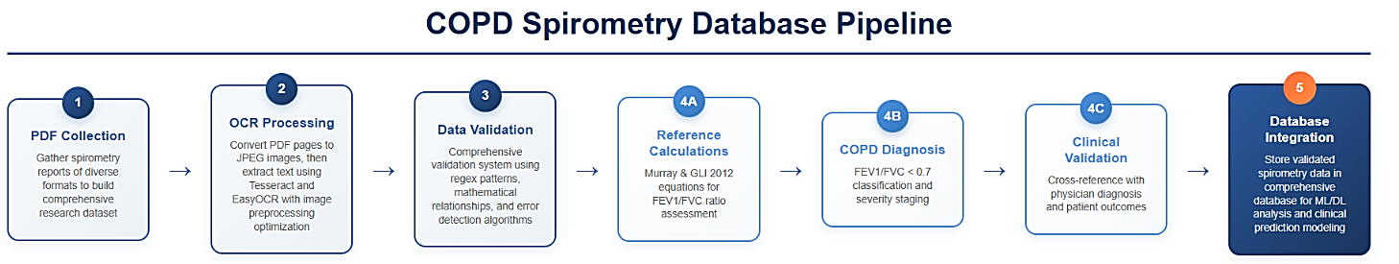
Multiple threshold levels were tested for each image, and the threshold producing the highest number of valid matches was selected. Post-processing corrections were applied to mitigate common OCR errors (e.g., confusion between “0” and “O” or missing decimal points). Internal consistency checks were performed on related fields (such as pre-/post-bronchodilator values and percentage changes), with results flagged as valid, uncertain, or erroneous. Finally, extracted values are saved and integrated within the database—a large holistic Excel file. Concurrently, a thinner database consisting of selected predefined fields for easier visibility and accessibility is generated.
Figure 2. Workflow of the automated COPD spirometry database system. The pipeline integrates patient data acquisition, spirometry report extraction, OCR-based parsing, post-processing validation, and database integration, supporting both comprehensive and clinician-focused datasets.

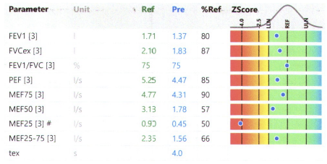
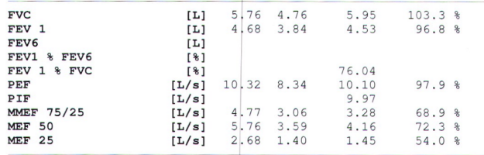

Figure 3. Examples of spirometry report formats processed by the extraction pipeline. (Left) “Old” format, presenting results in a simple tabular layout. (Right) “New” format, presenting results in a multi-column structure with graphical elements.

Validation of Extraction Accuracy

The accuracy of the extraction system was evaluated by manually comparing 20–35 reports from each recognized format against the corresponding machine-extracted outputs. Extraction performance was quantified as the percentage of correctly retrieved fields relative to the total number of available fields in each report. Reports that were scanned with severe artifacts, such as incomplete pages or significant tilting, were excluded from analysis. Correctness assessment included three complementary measures: (1) the percentage of correctly extracted fields, (2) the percentage of detected extraction errors, and (3) the percentage of undetected errors. This evaluation framework ensured that both overall system reliability and error detection performance were systematically captured.

Lung Function Analysis Module

Reference Value Calculations
The Global Lung Function Initiative (GLI) 2012 reference equations were implemented using the Lambda-Mu-Sigma (LMS) statistical framework. This approach models spirometric parameters (FEV₁, FVC, FEV₁/FVC ratio) across ages 3-95 years using three parameters: L (skewness), M (median), and S (coefficient of variation)[4]. Age-specific spline coefficients were obtained from the official GLI 2012 supplementary materials[4] and applied using interpolation methods to calculate precise reference values for any age within the valid range. Predicted values were calculated using the exponential form of GLI equations incorporating patient height, age, and ethnicity adjustments. Lower Limit of Normal (LLN) was determined using the GLI 5th percentile formula: $LLN = M× {(1 - 1.645·L·S)}^{1/L}$ providing age-adjusted diagnostic thresholds rather than fixed percentage cutoffs[5].

Traditional Murray reference
Equations were implemented for comparison using established linear regression coefficients with patient height and age as variables [6]. LLN were calculated as 80% of predicted values, consistent with historical clinical practice. The Murray approach utilizes fixed diagnostic thresholds independent of age-related physiological changes.

Diagnostic Classification Methods
Classification Algorithm for COPD diagnosis followed Global (GOLD) criteria, using the FEV₁/FVC < 0.70 threshold [1]. This classification was applied consistently to both Murray and GLI reference systems to enable direct method comparison. Disease severity was staged according to GOLD criteria based on FEV₁ percentage of predicted: mild (≥80%), moderate (50-79%), severe (30-49%), and very severe (<30%).
Comparative Analysis
A systematic comparison between Murray and GLI methods was implemented to evaluate diagnostic agreement and identify cases of methodological discordance. Both reference systems were applied to identical patient data, and diagnostic outcomes were compared for consistency, with the clinical significance of disagreements assessed.
Clinical Decision Support System
An automated screening algorithm was developed to identify obstructive spirometry patterns and generate diagnostic suggestions [7]. Extracted values were compared against established diagnostic thresholds, and structured recommendations, including severity classification and supporting criteria, were provided. This approach standardized initial diagnostic assessment while maintaining physician oversight of final clinical decisions.
Physician Integration Workflow
The diagnostic support system incorporated physician confirmation mechanisms, enabling clinicians to accept automated suggestions or provide alternative interpretations. This hybrid approach combined algorithmic consistency with clinical expertise, ensuring that diagnostic decisions remained under medical supervision while benefiting from computational standardization.
3.5 Clinical Interface Development
User Interface Design
A clinical analysis interface was developed to integrate spirometry data extraction, reference value calculations, and diagnostic support. The interface enabled real-time processing of uploaded spirometry reports with simultaneous display of both the source documents and calculated results. Users were provided with the option to apply Murray equations, GLI 2012 equations, or comparative analysis modes according to clinical requirements.
Quality Assurance Methods
Comprehensive input validation procedures were implemented for both demographic and spirometry data. Age values were restricted to 3–95 years in accordance with GLI equation validity, and height measurements were validated within physiologically reasonable ranges (100–250 cm). Mathematical consistency checks were applied to ensure plausibility of derived parameters. Error handling mechanisms were incorporated to detect incomplete or invalid data, and automated feedback was provided to guide users in resolving identified issues before analysis proceeded.
3.6 Data Management
Patient spirometry data were integrated into a structured database designed to support longitudinal analyses and historical comparisons. The system enabled patient identification through multiple search criteria and maintained diagnostic histories for tracking disease progression and treatment response over time. All diagnostic calculations and interpretations were documented with timestamp tracking and audit-trail functionality. This approach facilitates reproducibility of diagnostic decisions and supports retrospective quality assurance of algorithmic recommendations against clinical outcomes.

Results

Extraction program results
The core achievement of this project was the development of a robust and automated pipeline for extracting data from diverse spirometry report formats. A consistent difference in extraction time was observed between report categories defined in the Methods section. Formats classified as ‘old’ were processed in under two minutes per report, whereas formats classified as ‘new’ required approximately ten minutes per report. This variation reflected the structural complexity of the reports, with newer formats containing multi-column layouts and graphical elements that increased processing time. Using the validation protocol described above (Methods 3.3), the system achieved a high extraction rate, with over 80% of fields correctly identified and retrieved across all formats (Figure 4.1).
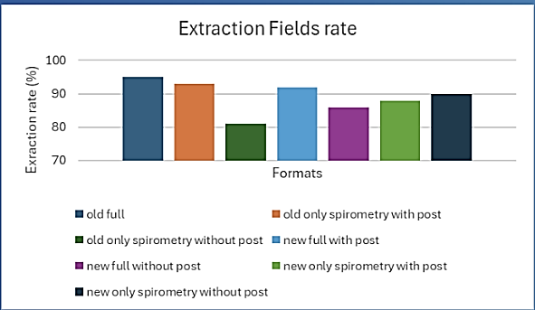
Error rates remained consistently low. The total proportion of errors (reported+ unreported), including those flagged by the internal validation system, was below 10% for all formats (Figure 4.2, right). Critically, the proportion of undetected errors alone remained below 5% across all formats, with most formats achieving less than 3% (Figure 4.2, left). These findings highlight the effectiveness of the post-extraction validation and correction procedures.

Figure 4.1. Extraction accuracy across spirometry report formats. Bars represent the percentage of correctly extracted fields per format

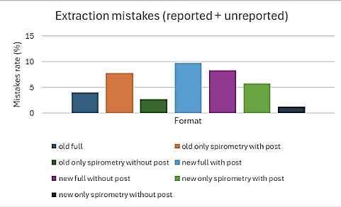
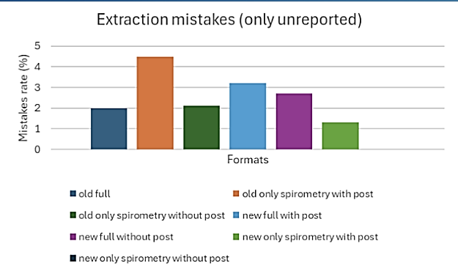

Figure 4.2. Extraction error rates across spirometry report formats. (left) percentage of only unreported mistakes remained below 5% across formats. (right) percentage of total mistakes (reported + unreported), showing overall error rates remained below 10% across formats.

Clinical Calculator Performance Analysis
Method Comparison: Murray vs. GLI Reference Systems
Validation analysis included 34 patients with complete spirometry data extracted from clinical PDF reports. The dataset comprised 21 females (62%) and 13 males (38%), with ages ranging from 33 to 87 years (mean 58.4 ± 18.2 years). Height measurements ranged between 154-180 [cm].
Parameter | Murray  Mean ± SD | GLI  Mean ± SD | Samples  [n] | Pearson  [r] | Paired T- Test  p-value | CCC | Mean Diff | SD Diff
FEV₁ (L) | 3.14 ± 1.13 | 3.20 ± 1.19 | 34 | 0.992*** | 0.061 | 0.989 | 0.053 | 0.161
FVC (L) | 3.97 ± 1.38 | 3.93 ± 0.96 | 34 | 0.780*** | 0.782 | 0.730 | -0.042 | 0.873
FEV₁/FVC | 0.786 ± 0.043 | 0.793 ± 0.024 | 34 | -0.027 | 0.381 | -0.022 | 0.008 | 0.050
Table 4.1. Statistical agreement between Murray and GLI prediction methods

FEV₁ predictions demonstrated near-perfect correlation (r = 0.992, p < 0.001) and strong concordance (CCC = 0.989) between Murray and GLI methods. The mean difference of 0.053 [L] was not statistically significant (p = 0.061). The scatter plot (Figure 4.3a) showed excellent agreement with minimal deviation from the identity line. FVC predictions showed substantial correlation (r = 0.780, p < 0.001) with lower concordance (CCC = 0.730) compared to FEV₁. No significant mean difference was observed between methods (p = 0.782, mean difference = −0.042 L). The scatter plot (Figure 4.3b) revealed greater variability around the identity line relative to FEV₁ predictions. FEV₁/FVC ratios exhibited poor correlation (r = -0.027, p = 0.381) between methods with minimal systematic difference (0.008, p = 0.381). The scatter plot (Figure 4.3c) demonstrated substantial scatter around the identity line, reflecting fundamental differences in ratio calculation approaches between reference systems.

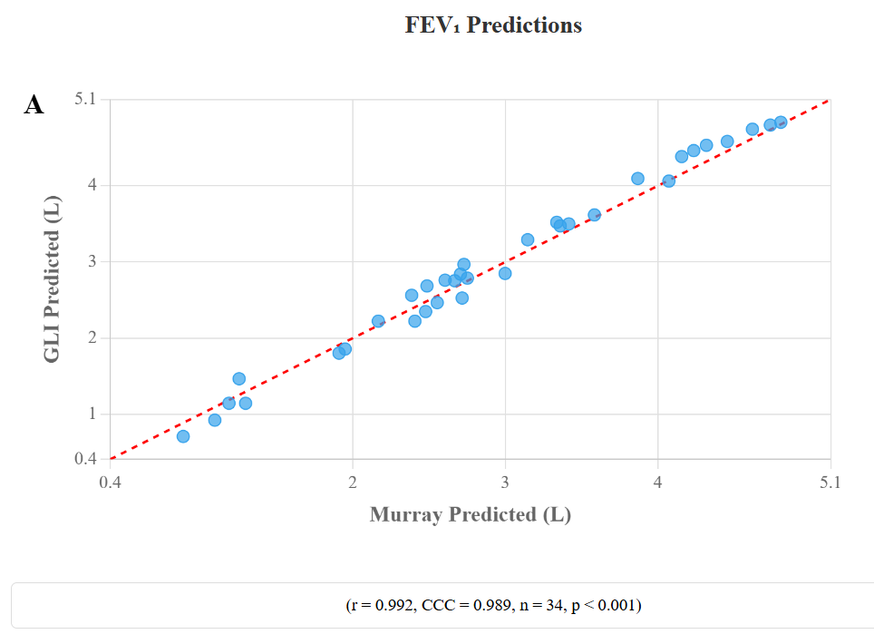
Figure 4.3. Comparison of predicted values between Murray and GLI reference methods.
Top to bottom: (A) Scatter plot of predicted FEV₁ values showing near-perfect correlation (r = 0.992, p < 0.001) and high concordance (CCC = 0.989) between methods. The mean difference of 0.053 L was not statistically significant (p = 0.061).
(B) Scatter plot of predicted FVC values showing substantial correlation (r = 0.780, p < 0.001) with lower concordance (CCC = 0.730) relative to FEV₁. No significant mean difference was observed (p = 0.782, mean difference = −0.042 L).
(C) Scatter plot of predicted FEV₁/FVC ratios showing poor correlation (r = −0.027, p = 0.381) between methods, with minimal systematic difference (0.008, p = 0.381).

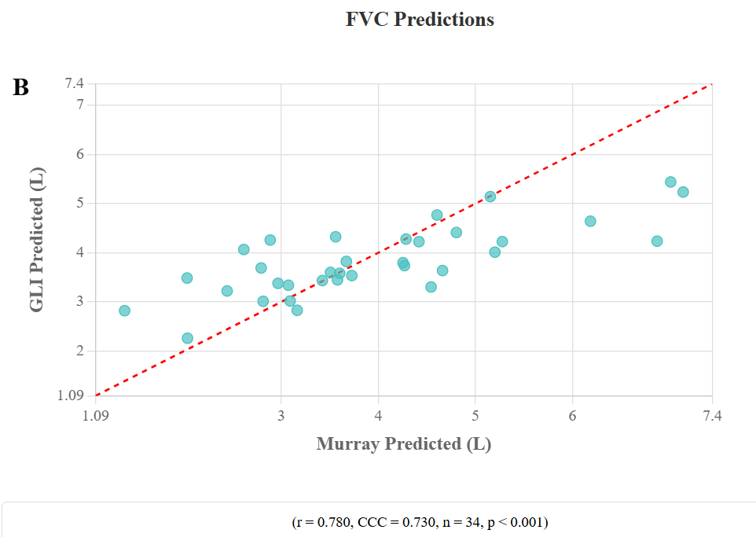

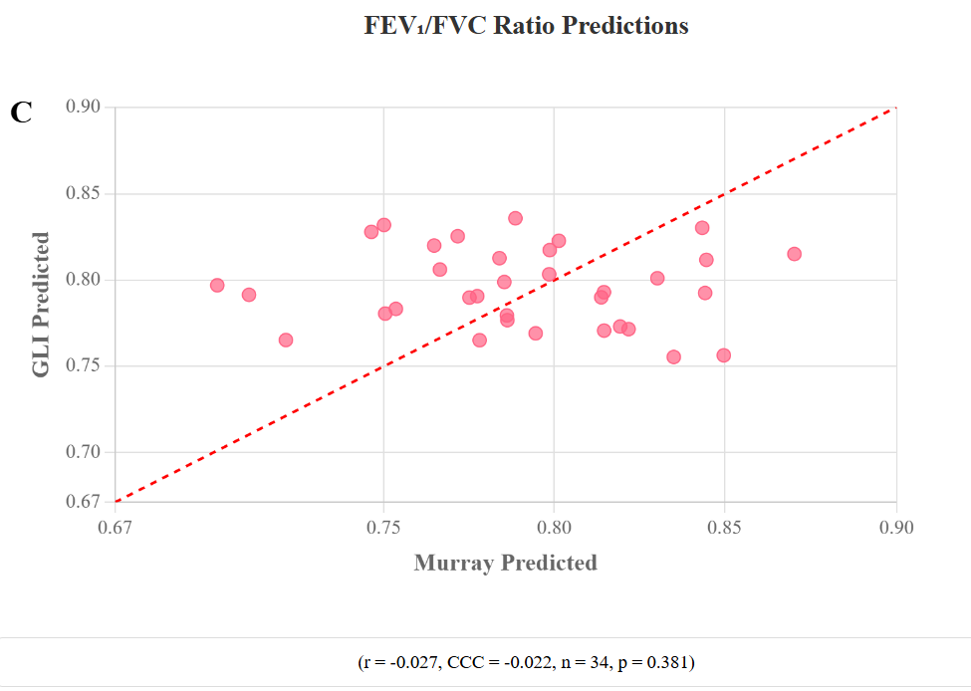

Diagnostic Agreement Analysis
The diagnostic agreement analysis revealed an overall agreement rate of 84.8% (28 of 33 patients). Cohen's kappa was 0.000, indicating agreement no better than chance. The contingency table showed unidirectional disagreement with 5 patients classified as COPD-positive by Murray but normal by GLI, and 0 patients classified as COPD-positive by GLI but normal by Murray. McNemar's test approached significance (p = 0.0625). Both methods agreed on normal classification for 28 patients, with no patients classified as COPD-positive by both methods.
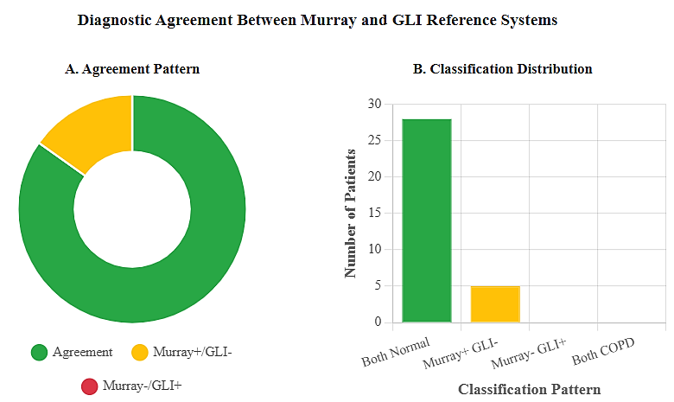

Figure 4.4. Diagnostic agreement between Murray and GLI reference systems for COPD classification using the FEV₁/FVC < 0.70 threshold. (A) Agreement pattern showing concordance and systematic disagreement: Murray classified five patients as COPD where GLI classified them as normal, while no patients were classified as COPD by GLI but normal by Murray. (B) Classification distribution showing agreement in 28 normal cases.

- Discussion

Creation of a COPD database
This project successfully addressed a critical challenge in COPD research and diagnostics: the absence of a structured, high-quality, and scalable spirometry database. By developing an automated data extraction pipeline, we transformed thousands of heterogeneous, image-based PDF reports into a unified, quarriable, and analysis-ready resource.

The system’s ability to handle seven distinct report formats using a dual-engine OCR strategy with dynamic thresholding demonstrates a sophisticated solution to a complex real-world problem. With extraction accuracy exceeding 80% and unreported error rates consistently below 5%, the reliability of the processed data can be considered high. Data integrity is essential, as the quality of downstream analyses depends directly on the robustness of the underlying dataset. The resulting database currently contains approximately 18,000 processed spirometry tests, including data from 1,134 patients with a confirmed COPD diagnosis. Notably, more than 540 patients have multiple follow-up tests, with some having five or more longitudinal assessments. This feature uniquely positions the database to support studies on disease progression, treatment response, and deterioration trends. Such longitudinal perspectives are especially valuable given the well-recognized gaps in COPD monitoring and prognosis.
In summary, this project represents a significant step toward bridging the gap between routine clinical data collection and advanced computational analysis. Beyond the technical achievement, the creation of a comprehensive and scalable spirometry database provides an important resource for future research. This foundation may enable the application of machine learning and predictive modeling, ultimately contributing to improved patient stratification, personalized interventions, and earlier identification of clinical outcomes in COPD.

Clinical Implementation and Physician-Driven Requirements
The clinical relevance of integrating both Murray and GLI reference systems was reinforced by direct physician input during system development. Our project supervisor, a practicing pulmonologist, emphasized the importance of comparing traditional Murray equations with GLI 2012 standards, noting that computational complexity remains a key barrier to GLI adoption in daily clinical practice, despite its advantages in age adjustment and accuracy.
This feedback directly shaped the system’s architecture by incorporating automated calculations for both reference methods. In doing so, the tool removes the need for clinicians to manually perform complex interpolations, providing simultaneous outputs from Murray and GLI standards within a single interface. This feature not only enhances usability but also empowers clinicians to make evidence-based decisions without additional computational burden. Beyond individual patient assessments, the system addresses broader challenges in clinical workflow integration. By adapting to variations across different spirometry equipment and report layouts, it overcomes interoperability barriers that often hinder seamless data utilization. In this way, the system aligns technical innovation with practical clinical needs, ensuring its potential for adoption in real-world environments.
5.3 Limitations and Future Work
While this project demonstrates the feasibility of automated spirometry data extraction and database construction, several limitations should be noted. First, the system’s accuracy remains dependent on the quality of scanned PDF reports; poor resolution or distorted layouts may reduce extraction reliability. Second, validation was performed on a relatively small cohort of 34 patients, which, although sufficient to demonstrate proof of concept, limits the generalizability of the performance metrics. Third, the system was adapted to seven known report formats, and additional development may be required to accommodate other formats or data sources from different institutions.
Future work should expand validation to larger and more diverse patient populations, ideally across multiple clinical centers. Enhancements in OCR and natural language processing could further improve extraction accuracy and robustness in the presence of poor scan quality. Beyond technical refinements, the database’s scalability provides opportunities for longitudinal research, integration with electronic health records, and advanced analytics such as machine learning for prognosis, biomarker discovery, and COPD sub-phenotype identification. These directions have the potential to strengthen both the clinical utility and the scientific impact of the system.

Conclusions
This work demonstrates the feasibility and clinical value of automating spirometry data extraction for COPD research and care. The Python-based system achieved over 80% extraction accuracy across seven distinct report formats, with fewer than 5% undetected errors in key clinical fields. A central achievement was the integration of GLI reference values, which represent the clinical gold standard but are rarely implemented in practice due to computational complexity. By embedding these calculations into the automated pipeline, the system removes a longstanding barrier to GLI adoption and enables more standardized, precise, and clinically relevant assessments.
From a technical perspective, the project established a scalable and validated framework. Automated extraction was successfully applied to heterogeneous report structures, supported by internal validation through mathematical consistency checks. The resulting database—currently encompassing more than 28,000 processed reports—is both robust and extensible, with architecture designed to support machine learning and deep learning applications. Importantly, the system reduces manual review time without compromising diagnostic accuracy, thereby improving both efficiency and reliability in data-driven clinical workflows.
Looking ahead, the database opens several avenues for impact. These include predictive modeling of COPD deterioration, identification of novel biomarkers, classification of disease sub-phenotypes, and large-scale population health analytics. The ability to track patients longitudinally further enhances the potential for prognostic research and personalized treatment strategies. Ultimately, by bridging the gap between computational methods and routine practice, this system contributes not only a valuable research resource but also a practical clinical tool that can advance early detection, patient stratification, and individualized care in COPD.
References
[1] Global Initiative for Chronic Obstructive Lung Disease (GOLD), “GOLD-2025-Report-v1.0-15Nov2024_WMV,” 2025.
[2] J. Perret et al., “Undiagnosed and ‘overdiagnosed’ COPD using postbronchodilator spirometry in primary healthcare settings: A systematic review and meta-analysis,” BMJ Open Respir Res, vol. 10, no. 1, May 2023, doi: 10.1136/bmjresp-2022-001478.
[3] “Chronic obstructive pulmonary disease: Risks, symptoms and prevention - Mayo Clinic News Network.” Accessed: Aug. 06, 2025. [Online]. Available: https://newsnetwork.mayoclinic.org/discussion/chronic-obstructive-pulmonary-disease-risks-symptoms-and-prevention/
[4] P. H. Quanjer et al., “Multi-ethnic reference values for spirometry for the 3–95-yr age range: the global lung function 2012 equations,” European Respiratory Journal, vol. 40, no. 6, pp. 1324–1343, Nov. 2012, doi: 10.1183/09031936.00080312.
[5] S. Stanojevic et al., “ERS/ATS technical standard on interpretive strategies for routine lung function tests,” European Respiratory Journal, vol. 60, no. 1, Jul. 2022, doi: 10.1183/13993003.01499-2021.
[6] J. F. Murray and J. A. Nadel, “Chapter 32: Pulmonary Function Testing: Interpretation and Applications,” in Murray and Nadel’s Textbook of Respiratory Medicine, 7th ed., 2025, ch. 32: Pulmonary Tests, p. 447.
[7] F. Velickovski et al., “Clinical decision support systems (CDSS) for preventive management of COPD patients,” J Transl Med, vol. 12, Nov. 2014, doi: 10.1186/1479-5876-12-S2-S9.

